Name: __________________________________________________________ Date: ____________________________

Comparing Linear Functions
- The functions f(x) and g(x) are described below. Compare the rate of change and intercepts of each.
x | g(x)
-2 | -10
-1 | -8
0 | -6
1 | -4

- Your employer has offered two pay scales for you to choose from. The first option is to receive a base salary of $250 a week plus 15% of the price of any merchandise you sell. The second option is represented in the graph below. Compare the rate of change and intercepts of the functions. What does the rate of change tell you about the two scales? When would each scale be better than the other?
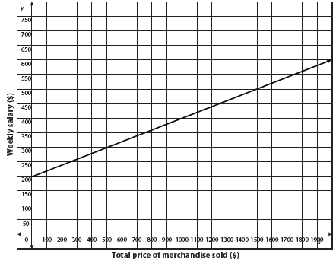

- Two airplanes are in flight. The function f(x) = -100x + 3,350 represents the altitude, f(x), of one airplane after x minutes. The graph below represents the altitude of the second airplane. Compare the rate of change and intercepts of the functions. Would the two planes ever be at the same altitudes? Which plane will reach the ground first?
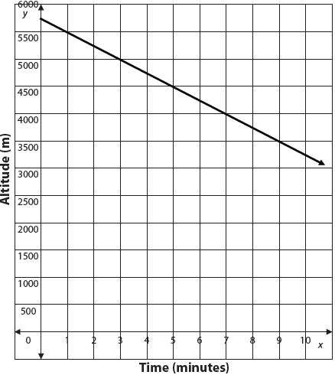

- Compare the rate of change of each function.
Function A Function B
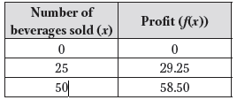
For each hamburger sold, the restaurant makes $0.40.

Comparing Exponential Functions
- Graph the two functions.
Which function has a greater rate of change over the interval [0, 5]?

How do you see that in the graph?

Which function has the greater y-intercept?

- Compare the rate of change of each exponential function over the interval [1, 3]. Find the common ratio, r, for the two functions. Will Function B ever surpass the value of Function A?
Function A Function B
x | g(x)
0 | 52
1 | 54.08
2 | 56.24
3 | 58.49
4 | 60.83
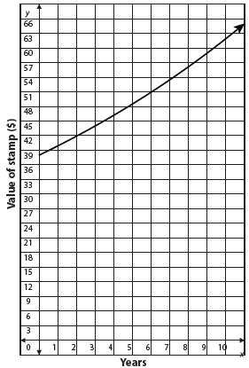

- Jennifer has the choice of two bank accounts. She has $2,000 to invest. Compare the rate of change for the two banks over the first 10 years. Which account is better than the other? What part of the equation would indicate that this bank is better than the other?

Bank A:

Bank B:

